2018-2019 Choraliers Uniform Requirements

Men’s uniform-order from Stage Accents-
- Men-Full tuxedo-Jacket, Pants and white wing collared shirt-$94
- Premier Tux Ensemble Item#: ENSB color-blackMen’s
- vest-Wave Vest Item#: 8816 color-wineMen’s-$39.00
- bow tie-Wave Bowtie Item#: 6025 color-wine-$7.00

Cuff links will be purchased from Ms. Rogers-$5.00

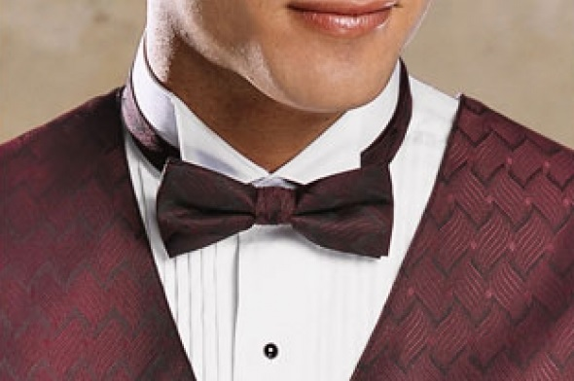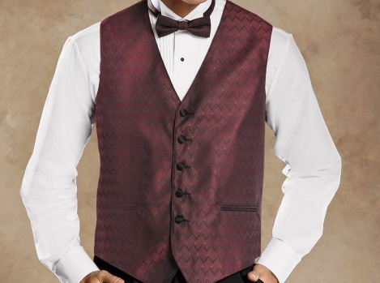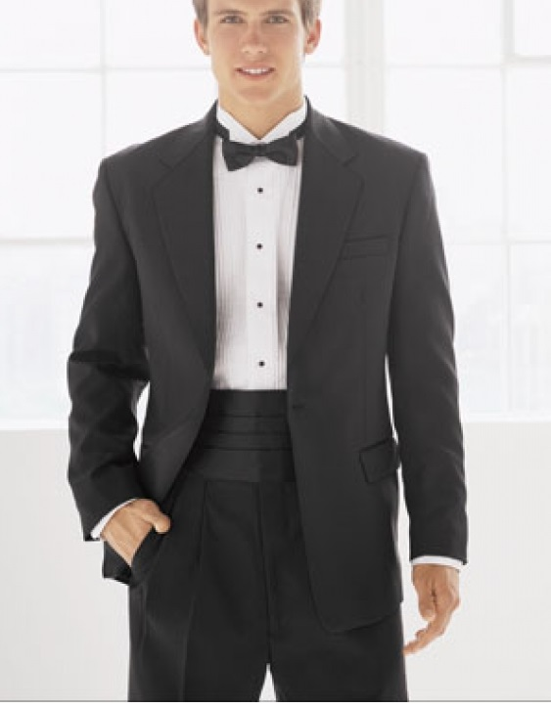http://www.stageaccents.com/

http://www.stageaccents.com/

Women’s Uniform-order from Stage Accents

Skirt-Gramercy Skirt Item#: 8744--$39.00

Top-Gwenn Top S/S Item#: 8722--$39.00

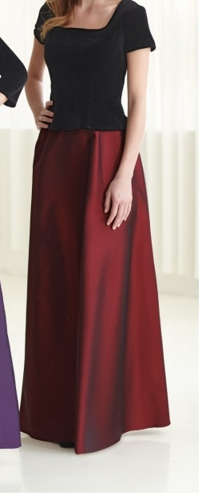
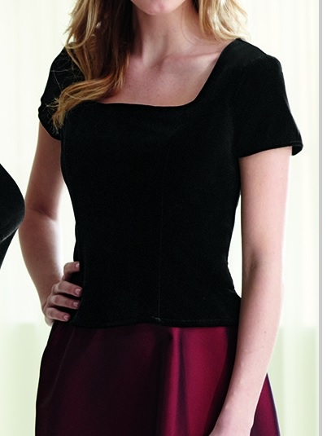
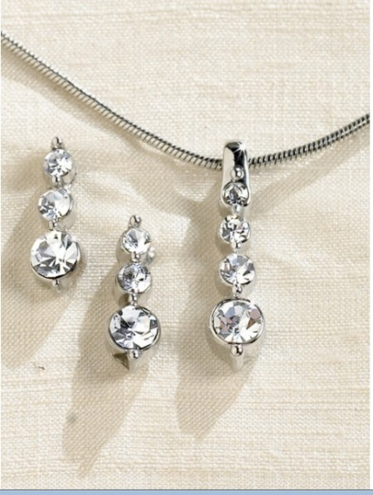
Jewelry will be purchased from Ms. Rogers-$20.00

